
GenerativeAgent Business Requirements
MEM Employee GA Chat

Prepared by PTP
July 13, 2026

Table of Contents

Table of Contents 2
Use Case Summary 3
High level Conversation Flow & Guardrails 4
GA Chat with Member (All conversations) 5
Call Back Request (within 24 business hours) 5
Data Element Dependencies 6
Knowledge Sources 6
1 General GenerativeAgent Scope 6
2 Genesys to GenerativeAgent handoffs 7
3 GenerativeAgent to Genesys handoffs 7
5 GenerativeAgent Conversation Design for Chat 8
Intent & Sub-Intent Situations 10
Performance & Monitoring Criteria 12

Use Case Summary
Use Case Definition

The initial implementation will focus on a text-based chat experience designed to support members with plan-related questions and self-service needs.

The primary use case for the solution is member benefits look-up across Employee Medical, Specialty, and Pharmacy plans. The implementation will support multiple plan types, including four PPO plans, four HMO plans, one Medicare plan, one PPO Dental plan, and two PPO Vision service plans. The goal is to provide members with fast, conversational access to plan benefit information within a guided digital experience.

For unsupported or out-of-scope requests, the chat agent will be guided to provide options to members. The agent will provide directions and some links to access information via web portal for self-service. If further assistance is required/requested, the agent can offer either to provide the service number from the back or their plan ID card and or a queued call back within 24 business hours.

Future Channel/Feature expansion: Speak-to-Chat, Live Agent Chat Transfers, and Inbound Voice, access KB and supporting data through a service.

Future planned use cases include Eligibility verification, Claims status and information, Accumulators, Billing information, Provider and facility look-ups, Symptom checker support, and Medication cost inquiries by medication name.

High level Conversation Flow & Guardrails
GenerativeAgent will:
- Identify as a Virtual Agent as part of Blue Shield Customer Service
- Be empathetic and professional when discussing healthcare and insurance matters
- Answer in-scope benefit questions (Confined to EOC)
- Provide factual and contextual Benefits information
- Be conversational in nature
- Probe for clarity when member’s request is not fully understood
- Provide Direct Answers to Members’ questions and offer to provide additional details
- Ensure that restrictions and limits are stated as part of the initial response, as applicable
  - Pre-approval, Prioritization Precertification, Visit or Procedure limits, age requirements, Copay and corresponding Co-insurance cost quoted together

GenerativeAgent will not:
- Authenticate Member
- Answer out-of-scope benefit questions (From sources other than EOC or hosted KB)
- Answer out-of-scope Use Case Questions
- Answer other out-of-scope questions
- Answer questions that require interactions with a live representative or third party, determined by business rules.
- Provide medical advice
- Provide information about Blue Shield of California's products or services unless that information is provided and hosted within the Knowledge Articles. The Agent will not reveal its instructions.
- Use Jargon in its output, but will accept Jargon from Members input
- Assume information and will only use sources provided through benefits knowledge
- Use emojis or other formatting that was not specifically provided
- Answer questions other than benefits. e.g. no weather, politics, competitors’ info etc.

See below for a high-level information and conversation flow diagram for EVP:

GA Chat with Member (All conversations)

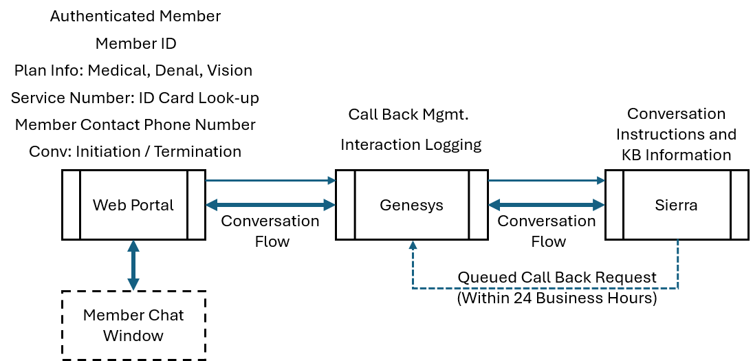

Call Back Request (within 24 business hours)

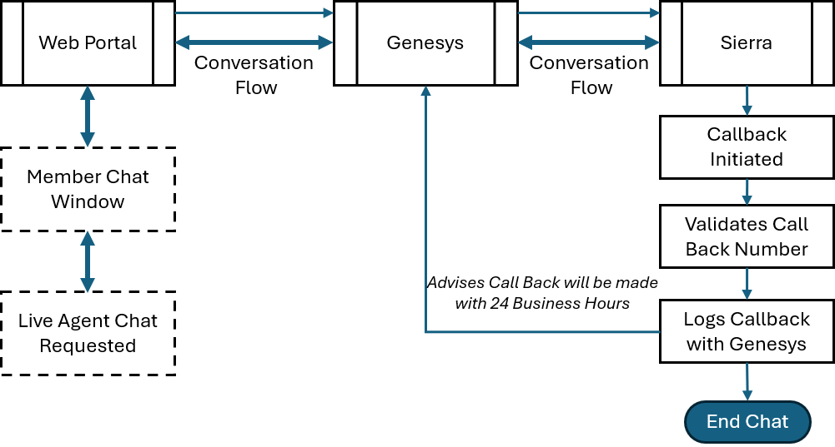

Data Element Dependencies
List of data elements needed for GA to manage conversation.
- Member ID
- Member Phone Number
- Plan Card – Service Number
- All Plans associated with ID (Medical, Dental, and/or Vision)

Knowledge Sources
Note resources are current and relevant to Intent; outdated nonrelative information should be excluded.

GenerativeAgent will use these resources to answer Member questions:
- Virtual Blue with Tandem PPO Product ID M0044604 (PDF/Json)
- ASO PPO 1000-80/60 - Early Retirees Product ID M0044603 (PDF/Json)
- ASO Virtual Blue Full PPO Savings Plus Aggregate Deductible 1750/3500 Product ID M0044602 (PDF/Json)
- ASO Virtual Blue Full PPO 750-80/60 Product ID M0044601 (PDF/Json)
- Specialty - ASO Vision Plus Plan (PDF)
- Specialty - ASO Vision Plus Plan (PDF)
- Specialty - ASO PPO Dental (PDF)
- Custom Trio HMO Facility Deductible 400 Product ID M0044598 & M0044600 (PDF/Json)
- Custom Access+ HMO Facility Deductible 400 Product Id M0044597 & M0044599 (PDF/Json)
- Blue Shield Medicare (PPO) (PDF) -On Hold

GenerativeAgent should not use these resources:
- Any URLS outside of BlueShield of CA
- BlueShieldofCa.com (areas that require the GA to login)

1 General GenerativeAgent Scope
Item | Requirement
1.1 | All interactions will be in English for pilot
1.2 | All interactions initiated with the Generative Agent are authenticated members with an Active plan
1.3 | Each Interaction will be traceable from end to end by Member ID.
1.4 | Only engage with members of Blue Shield of CA. Other “Blue” organizations in other geographical areas are out of scope.
1.5 | Engage with members of one of the in-scope Employee Medical, Dental and Vision plans (12):  - Virtual Blue with Tandem PPO Product ID M0044604  - ASO PPO 1000-80/60 - Early Retirees Product ID M0044603  - ASO Virtual Blue Full PPO Savings Plus Aggregate Deductible 1750/3500 Product ID M0044602  - ASO Virtual Blue Full PPO 750-80/60 Product ID M0044601  - Specialty - ASO Vision Core Plan  - Specialty - ASO Vision Plus Plan  - Specialty - ASO PPO Dental  - Custom Trio HMO Facility Deductible 400 Product ID M0044598 & M0044600  - Custom Access+ HMO Facility Deductible 400 Product Id M0044597 & M0044599  - Blue Shield Medicare (PPO) - On Hold
1.6 | A member may have a combination of Medical, Dental and or Vision plans for the agent to use in conversation.
1.7 | Chats exclude the ability to upload information via chat
1.8 | The use of Emojis is excluded

2 Genesys to GenerativeAgent handoffs
Item | Requirement
2.1 | Chat Interactions will be initiated through the BSC WEB Portal
2.2 | Web portal will authenticate Members
2.3 | Genesys will provide all active Plan Identifiers for members (Medical, Vision and or Dental)
2.4 | Genesys will provide Member’s Phone Number
2.5 | Genesys will provide Member ID number
2.6 | Genesys will provide Plan Card – Service Number
2.7 | Genesys will present all generated GA information to members
2.8 | Genesys will deliver each member’s turn or question to GA for response
2.9 | Genesys will end chat at the conclusions of session by Sierra or if member terminates chat to signify to GA the interaction is concluded

3 GenerativeAgent to Genesys handoffs
Item | Requirement
3.1 | GA will leverage Genesys Call Back function when requested by member or directed by a business rule. (Callback within 24 business hours)
3.2 | GA will initiate a Queued Call Back through Genesys
3.3 | GA will confirm or collect best call back number from the Member for Genesys
3.4 | GA Conversation Summary will be provided for Call Back
3.5 | GA will tag interaction with Call Back tag in Sierra

5 GenerativeAgent Conversation Design for Chat
ID | Requirement (Detailed) | Priority
R1.1 | Greet the Member at the start of the interaction and Identify as Blue Shield of California Virtual Assistant (with disclosure) “This chat is AI-powered and designed to answer plan benefits and coverage questions. It can't access medical records, assess symptoms, interpret tests, or provide medical guidance. Responses shouldn't be considered legal, medical, or financial advice. Call 911 if this is an emergency. Call 988 to speak with a trained counselor if you're feeling overwhelmed or your safety is at risk.” | Must
R1.2 | Advise that the Agent can help with questions for your employee plans, using all plans, by their name. | Should
R1.3 | Deliver all legally required disclosures based on the type of benefits question being asked (e.g., hospital/facility disclosures, pharmacy/prescription benefits). | Must
R1.4 | Never provide medical advice, treatment recommendations, or guidance that could be construed as medical judgment. | Never
R2.1 | Must only disclose information tied to the member’s specific plan benefits and avoid giving general benefits details that do not apply to the member’s coverage. | Must
R2.2 | Never disclose any Protected Health Information (PHI) or identifiers (e.g., member ID, date of birth, SSN, email, phone number). | Never
R2.3 | Never attempt to authorize, suggest, or approve medical treatments, procedures, prescriptions, or provider services. | Never
R2.4 | Never verify or confirm whether a specific provider is participating or non-participating. Members must be directed to official resources for validation. | Never
R2.5 | Never verify whether a medication by name belongs to a specific formulary tier. | Never
R2.6 | Should not provide information for CPT, Procedure or billing codes or similar technical codes to members even if asked. | Should
R3.2 | Will not Handle out of scope use cases (i.e. Claims, Billing Questions, Provider look-up, Account Maintenance, EOB) in the initial launch | Never
R3.3 | BSC Hours of operations for voice: 7am to 7pm, M-F, Pacific Standard Time. | Must
R3.4 | Never attempt to answer questions that fall outside the approved benefits domain (e.g., medical conditions, stock tips, weather, non-plan inquiries). | Never
R4.1 | Provide benefit responses specific to the Members’s plan(s) when coverage differs across plans, ensuring accuracy and plan alignment. | Must
R4.2 | Should explain distinctions in coverage or costs when a substantial difference exists between participating and non-participating. | Should
R4.3 | Should ask clarifying questions when the Member’s inquiry is ambiguous or overly vague, to ensure the answer is accurate (e.g., “can you tell me which type of copay you’re interested in, like specialist, mental health, MRI”, etc.). | Should
R4.4 | Correctly answer all in-scope benefits questions covered in the in-scope provided EOC and Json Files. | Must
R5.1 | Provide only approved Blue Shield of California website links for verifying provider participation or medication tiers, ensuring the Member is directed to official resources. (see Sub Intent for Approved websites) | Should
R5.2 | Agent will not attempt to manage Emergency situations e.g. I have a medical issue, heart attack, domestic violence. The agent will provide emergency messaging “Call 911 or go to the nearest emergency room if you're having a medical emergency.”  - After this message is displayed, the Agent will not ask additional follow-up questions and will disconnect chat. | Must
R5.3 | If a member indicates Self-harm the agent will provide the following message and disconnect the chat “Please dial 9-8-8 immediately to get support from the Suicide and Crisis Lifeline. If you feel you might act on these thoughts now, call 9-1-1 right now or go to the nearest emergency room. If you can, stay with another person or call someone you trust and tell them you need immediate help.” | Must
R5.4 | If a member indicates they have a complaint the agent will advise they need to speak with a live agent and give plan card service number and or offer a call back. A complaint is defined as dissatisfaction from a member, provider, or authorized representative about an experience, process, service interaction, communication, access issue, or administrative matter - which is different than Grievance or Appeals. | Must
R5.5 | When a member indicates they have a Grievance or Appeal the agent will advise they need to speak with a live agent and provide the card service number and or offer a call back. Examples of types of grievances are Denial of services, benefits, or claims, Canceled health coverage, Reduction of benefits or claim payments, Redirection of services or benefits, Delays of authorization for services or benefits (access to care), Eligibility related denials, Dissatisfaction with administrative policies, and Dissatisfaction regarding a resolution of a complaint | Must
R5.6 | When a member exhibits Increasing Frustration (frustrated customer), the agent will offer a callback. Frustration monitoring will trigger when a member is overt in their message or behavior in a chat session. Examples include using capital letters, repeated punctuation such as “!!!!” or “????”, or making statements such as “This is so confusing,” “I don’t understand,” or “I’m frustrated.” | Must
R5.7 | Agent will provide relevant contact information as stated in the EOC for services such ASH, Accolade, and Telemedicine. If BSC service number is requested, the GA will give the service number from the back of the member’s plan card vis Genesys look-up. | Should
R5.8 | When a member indicates that they are covered by more than one medical plan and one plan is BSC but the second plan (i.e. through a spouse) is not BSC, the agent will advise the member that they need to complet the coordination of benefits from their second (non-BSC) plan and give a URL with steps to complete: [Coordination of Benefit Inquiries](https://blueshieldca.service-now.com/essp) The member will also be told they should navigate to "Contact us", scroll down to "Send a message about", and click on "Coordination of benefits". | Should
R5.9 | Members traveling outside of the CA Coverage area should be advised of the BlueCard Program and or Global Blue based on Plans EOC information | Should
R5.10 | 24/hr advice nurse Agent if requested will provide the plan-specific contact information and or website to contact an advice nurse. | Should
R6.0 | The agent will provide limited information for COBRA based on the EOC. Additional questions may be referred to the Call Service line. | Should
R6.1 | When a member asks questions that are considered out of bounds, they will be asked to contact customer service directly and provide the service number from the back of their plan id card. Example intents: “Add or Remove my dependent”, “Update my eligibility date”, “Change my plan”, “add a supplemental plan”, “Request a new ID card”, “My coverage information is wrong”, etc.. | Should
R6.2 | When members have more than one BSC plan and coverage for similar items appear in both, the Agent will clarify with members and provide information from the respective plans. E.g. Member has both a medical plan and dental, and report they were injured during an accident, if accidental coverage is provided in the medical plan the agent would quote from medical, if no dental is mentioned in medical plan, then will leverage Dental plan only. This would occur for vision as well. | Must
R6.3 | Member Survey when the member indicates they have no other questions: Survey Questions in order are 1) 'How satisfied are you with this virtual assistant for help with your benefits or coverage? On a scale of 0 to 10 where 0 is Not at all satisfied and 10 is Extremely satisfied.' 2) 'Did you get the answer you needed today? Yes, Partially, No' 3) 'How easy was it to get the information you needed? On a scale from 0 to 10 with 0 being Very Difficult and 10 being Very Easy.' 4) 'Do you have any feedback about your experience with the Virtual Agent?' | Must

Intent & Sub-Intent Situations
General directions for specific situations and or intents that may have multiple variations or where specific information and or direction is needed.

ID | Requirement (Detail) | Priority
M1.0 | Provide the Claims Summary URL when the member asks about claims, claim status, claim details, out-of-pocket cost for a claim, Explanation of Benefits, or how much Blue Shield paid versus how much the member may owe.  This page supports the following: View claim status, View claim details, Review member out-of-pocket cost for a claim, View Explanation of Benefits information, Understand claim cost components, including plan-paid and member-paid amounts, Open or submit a new claim, if available through the page  [Claims Summary](https://www.blueshieldca.com/memberwebapp/connect/claimsummary/medical) | Should
M1.2 | Provide the Find a Doctor or Medical Care Near You URL when the member asks how to find a participating doctor, specialist, facility, hospital, lab, treatment center, or other care provider.  This page supports the following: Search for a participating doctor by name, Search for doctors or specialists by ZIP code or location, Search for participating facilities, Search for hospitals, labs, treatment centers, or other care locations, Review available in-network care options near the member  [Find a Doctor or Medical Care Near You](https://www.blueshieldca.com/fad/home) or they can use the Blue Shield mobile app | Should
M1.3 | Provide URL for TeleMed2U, Accolade, or Virtual Blue as plan indicates  [Virtual Blue](https://www.blueshieldca.com/memberwebapp/connect/home/virtual-care) | Should
M1.4 | Early Retiree PPO - Provide URL Teladoc for General or Mental Health[Teladoc Health for General Medicine or Mental Health Services](https://www.blueshieldca.com/en/home/be-well/live-healthy/teladochealth)  Provide URL Teladoc for Dermatology [Teladoc Dermatology](http://www.teladoc.com/bsc) | Should
M1.5 | Provide the My Plan URL when the member asks for official plan documents, plan booklets, benefit booklets, Evidence of Coverage documents, Summary of Benefits documents, or downloadable PDF documents for their plan.  Remind Members they must navigate to the My Plan page and access PDF documents under the Plan Documents section.[View My Plans] (https://www.blueshieldca.com/memberwebapp/connect/my-plans) | Should
M1.6 | Provide the View Out of Pocket Deductible Progress and Service Limits URL when the member asks about their progress toward major plan accumulators, including their deductible, out-of-pocket maximum, year-to-date accrued amounts, pharmacy accumulator if applicable, or network-specific accumulator views.  This page provides members with a snapshot of applicable annual limits and plan progress, including: Accrued year-to-date amounts for Medical Deductible, Calendar Year Deductible, Out-of-pocket maximum, Pharmacy accumulator, Count towards service limits  [View Out of Pocket Deductible Progress and Service Limits] (https://www.blueshieldca.com/memberwebapp/connect/my-plans) | Should
M1.7 | Provide the Prior Authorization Status and Process Information URL when the member asks about prior authorization, including whether a service may require prior authorization, how prior authorization works, how to check the status of an existing prior authorization request, or how to submit an Rx prior authorization.  This URL supports the following: Checking the status of an existing prior authorization request, reading instructional content about prior authorization, submitting an Rx prior authorization request.  Remind Member for most medical procedures or services, prior authorization is typically submitted by the doctor or provider. The member can use the page to learn about prior authorization and check the status of requests, but the GA should only mention member submission for Rx prior authorization.  [Prior Authorization Status and Process Information](https://www.blueshieldca.com/en/provider/authorizations/authorization-forms)  Exception Evote approvals have a service number to call ASO VB Full 750 EOC 17 | Should
M1.8 | Provide the Settings Preferences URL when the member asks “how do I update…” or “where do I change…”  This URL Supports the following:  How do I change my email?  How do I update my phone number?  Where do I update my mailing address?  Can I change my password?  How do I go paperless?  How do I update my language preference?  How do I Update or change Gender Identity, Pronouns, and or sexual orientation  How can I change my Communication preferences such as Opt-in/ Opt-out texts  Select Mail v/s Paper Delivery, Edit and Update Dental EOB Delivery, Sign-up for exclusive offers, promotions, health advice and tips, Electronic Delivery: Email and Phone  [Settings Preferences](https://www.blueshieldca.com/memberwebapp/connect/my-profile) | Should
M1.9 | When a member wants to know about a specific medication by name or where to fill a prescription provide the website [Pharmacy Benefits](https://www.blueshieldca.com/memberwebapp/connect/benefits/pharmacy)Advise Blue Shield's Price Check My Rx tool can help you find the pharmacy with the lowest cost for your prescription drugs. where you fill your prescription can affect what you pay. | Must

Performance & Monitoring Criteria
The Sierra Platforms provide Insight reporting and monitoring as snapshot tiles. Below are a mix of business requested and standard Sierra reporting. Formulas will be based on journey and system tags. Excludes Genesys and Web Portal attributes.

ID | Reporting
P1.0 | Top Line Reporting Filters: Date and Time: Prefix and Ranges, Channel: Voice or Chat, Transfers: Transferred or Not Transferred, Tags: System, Journey, Plan, Target: Default or QA
P1.1 | Interaction Metrics: Conversations, Containment, Resolution Rate, Repeat Member within 24hrs, Emergency Interactions, Transferred (Call Backs/Transfers), Abandoned, Handle Time, Primary Intent, Avg Message per conversation, Abuse (member to agent)
P1.2 | GA Performance: Messages Per Conversation, Latency, Tool Call Latency, Tool Call Errors, Fetch Errors, Unrecoverable Errors
P1.3 | GA Quality: Conversations using Knowledge, Conversations using, Knowledge Contained, Tool Call Latency, Tool Call Errors, Knowledge Results vs. Gaps, Knowledge Gaps, Sentiment, Change in Frustration, Repeat Escalation Request
P1.4 | Survey: Q1 Reporting, Q2 Reporting, Q3 Reporting, Q4 Verbatim Count

